Enter **Simulation** mode and enter the command **ping 172.16.31.3**. Two PDUs will be generated. The **ping** command cannot complete the ICMP packet without knowing the MAC address of the destination. So the computer sends an ARP broadcast frame to find the MAC address of the destination.

2 PDU was generated. 1 ARP, 1 ICMP

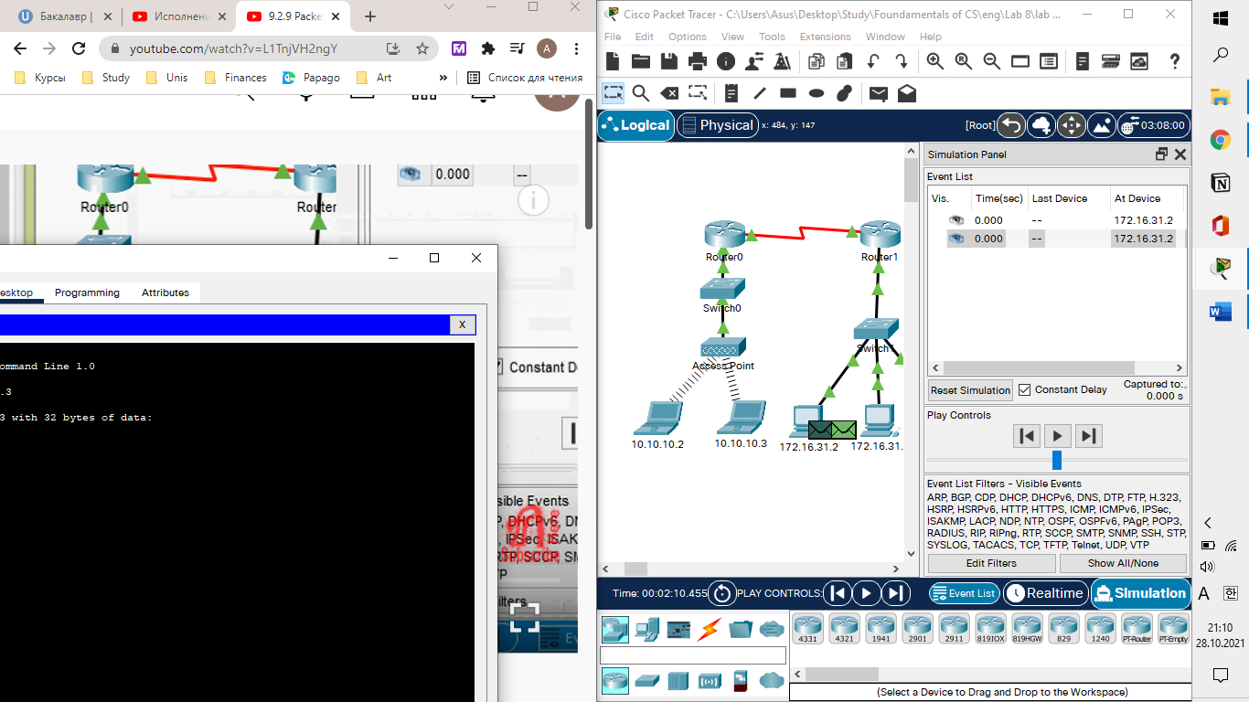

Click **Capture/Forward** once. The ARP PDU moves **Switch1** while the ICMP PDU disappears, waiting for the ARP reply. Open the PDU and record the destination MAC address. Is this address listed in the table above? No

ARP moved to switch1

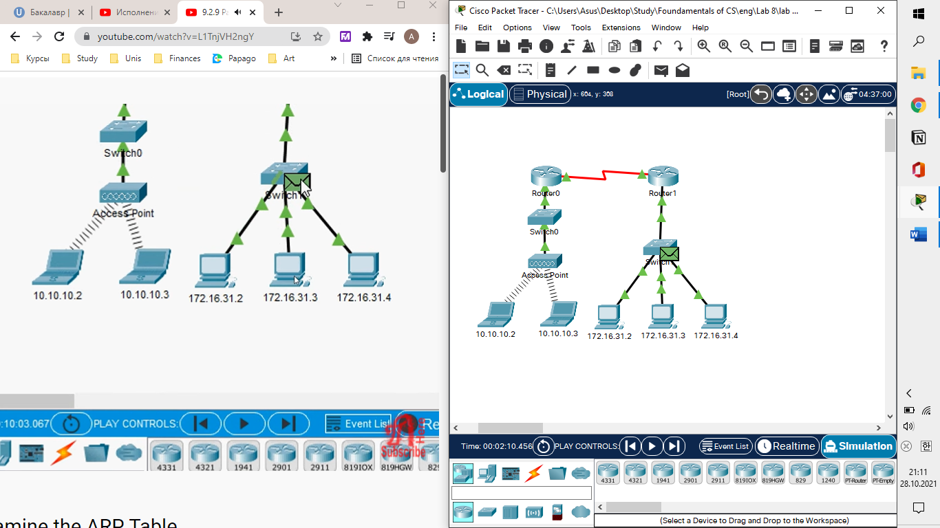

Click **Capture/Forward** to move the PDU to the next device. How many copies of the PDU did **Switch1** make? 3, 1 for 172.16.31.3, 1 for router1, 1 for 172.16.31.4

(the router and 172.16.31.4 didnt accept, there were red crosses)

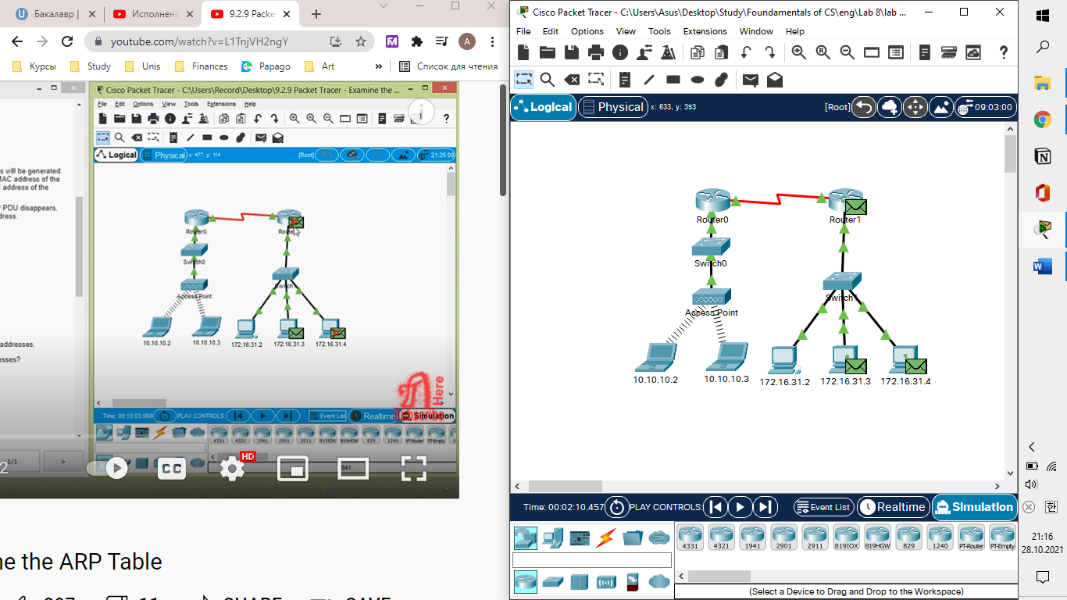

What is the IP address of the device that accepted the PDU? 172.16.31.3

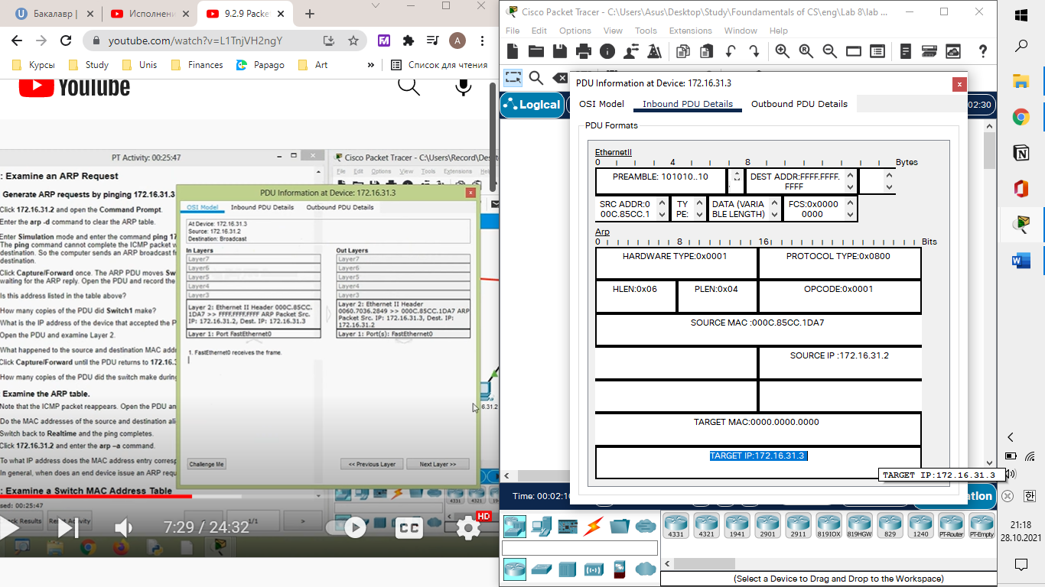

Open the PDU and examine Layer 2. What happened to the source and destination MAC addresses? Source became destination, FFFF.FFFF.FFFF turned into MAC address of 172.16.31.3

Click **Capture/Forward** until the PDU returns to 172.16.31.2. How many copies of the PDU did the switch make during the ARP reply? 1

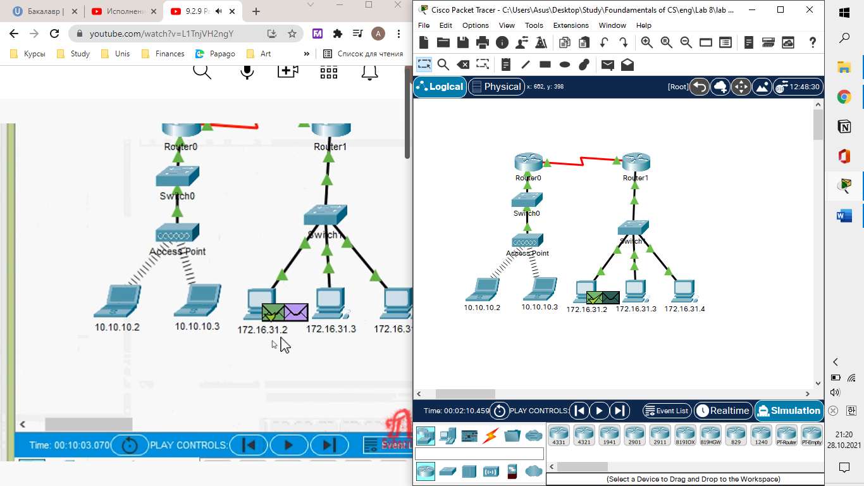

Note that the ICMP packet reappears. Open the PDU and examine the MAC addresses. Do the MAC addresses of the source and destination align with their IP addresses? Yes

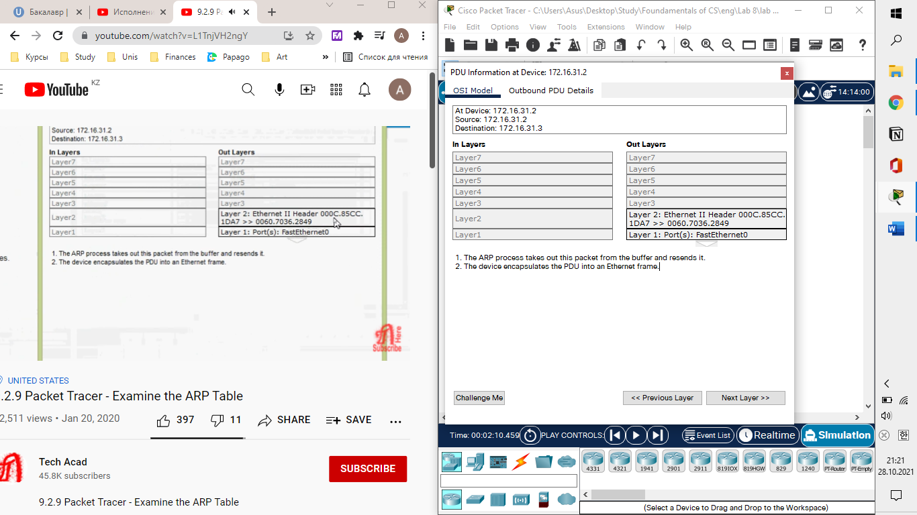

Switch back to **Realtime** and the ping completes.

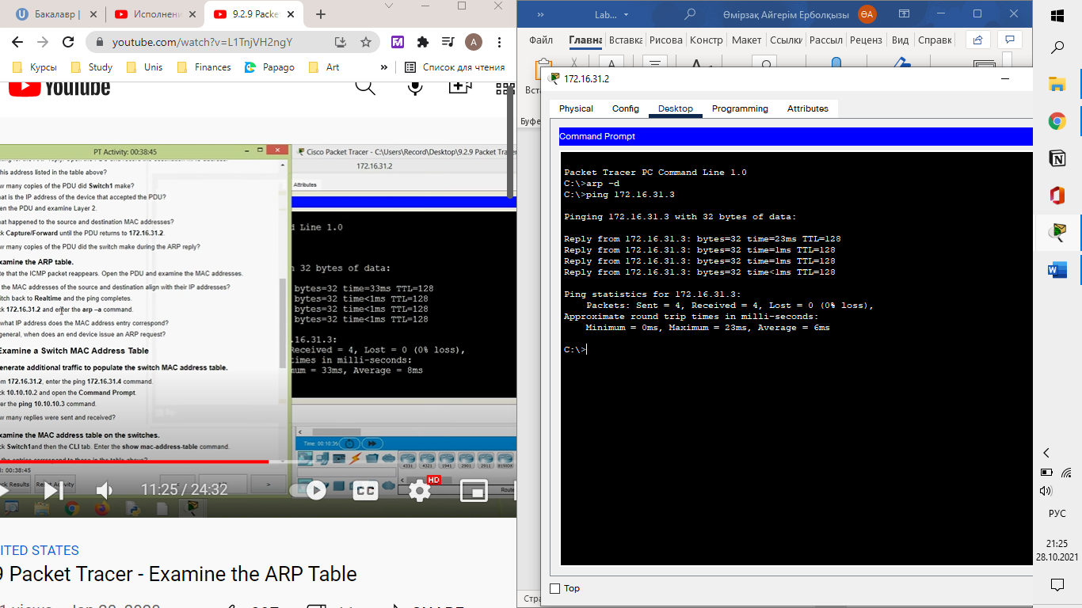

Click **172.16.31.2** and enter the arp -a command. To what IP address does the MAC address entry correspond? 172.16.31.3

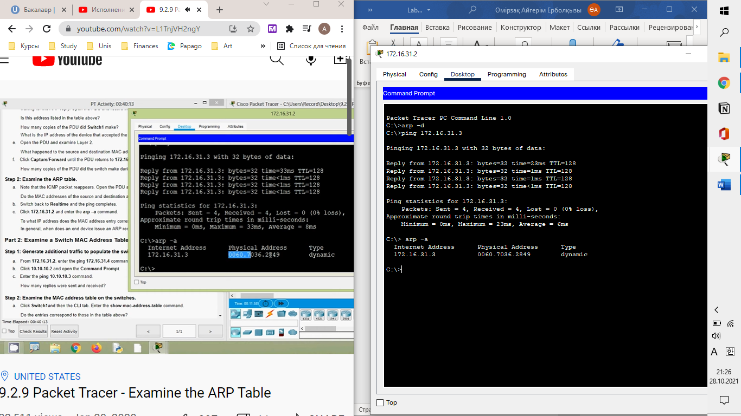

In general, when does an end device issue an ARP request? When it does not know the receiver’s MAC address.

Enter the ping 10.10.10.3 command. How many replies were sent and received? 4 sent, 4 received.

Enter the **ping 10.10.10.3** command. How many replies were sent and received?

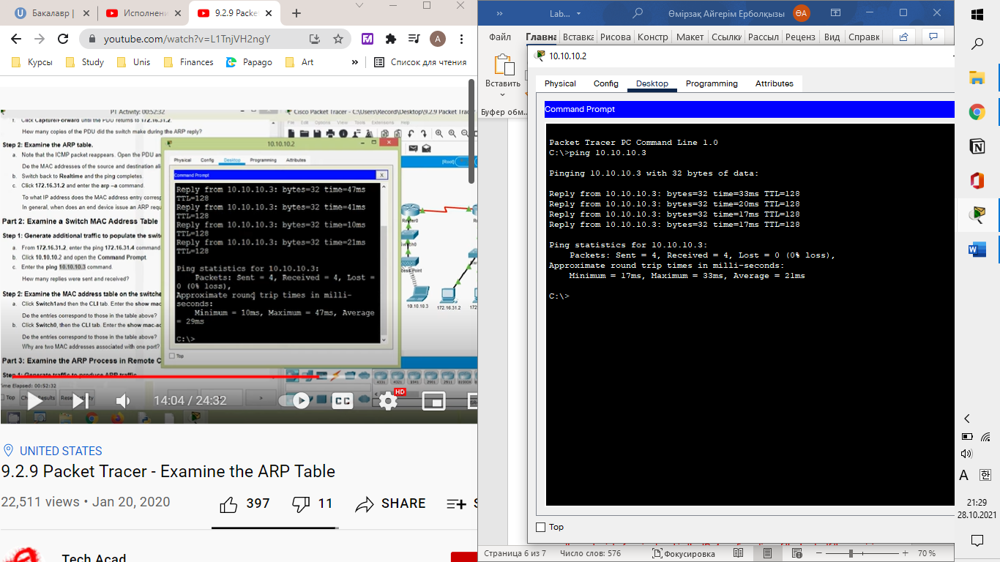

Click **Switch0**, then the **CLI** tab. Enter the show mac-address-table command.

Do the entries correspond to those in the table above? Yes

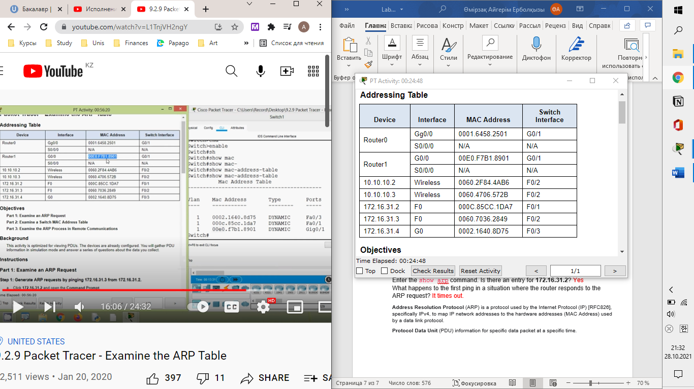  
Why are two MAC addresses associated with one port(F0/2)? Because both devices connect to one port through the Access Point.

Click **Switch1and** then the **CLI** tab. Enter the show mac-address-table command.

Do Do the entries correspond to those in the table above? Yes

 Type arp –a. What is the IP address of the new ARP table entry? 172.16.31.1

Repeat the ping to 10.10.10.1. How many PDUs appear? 2. 1 ICMp, 1 ARP

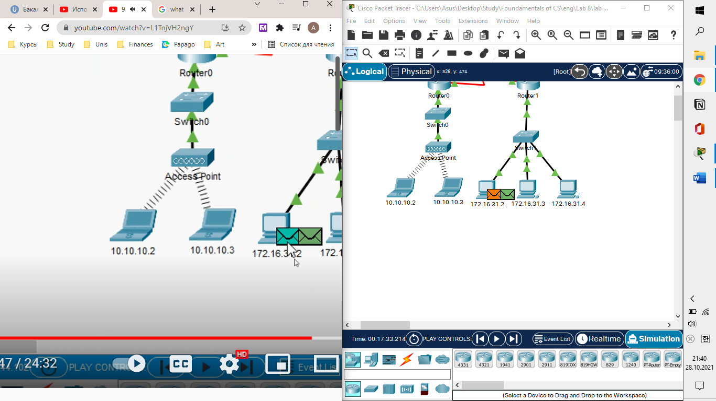

Click **Capture/Forward**. Click the PDU that is now at **Switch1**. What is the target destination IP destination address of the ARP request? 172.16.31.1

g. The destination IP address is not 10.10.10.1. Why? The gateway address of the router interface is stored in the IPv4 configuration of the hosts. If the receiving host is not on the same network, the source uses the ARP process to determine a MAC address for the router interface serving as the gateway.

Enter privileged EXEC mode and then the show mac-address-table command. How many MAC addresses are in the table? Why? Zero, This command means something completely different than the switch command show mac address-table.

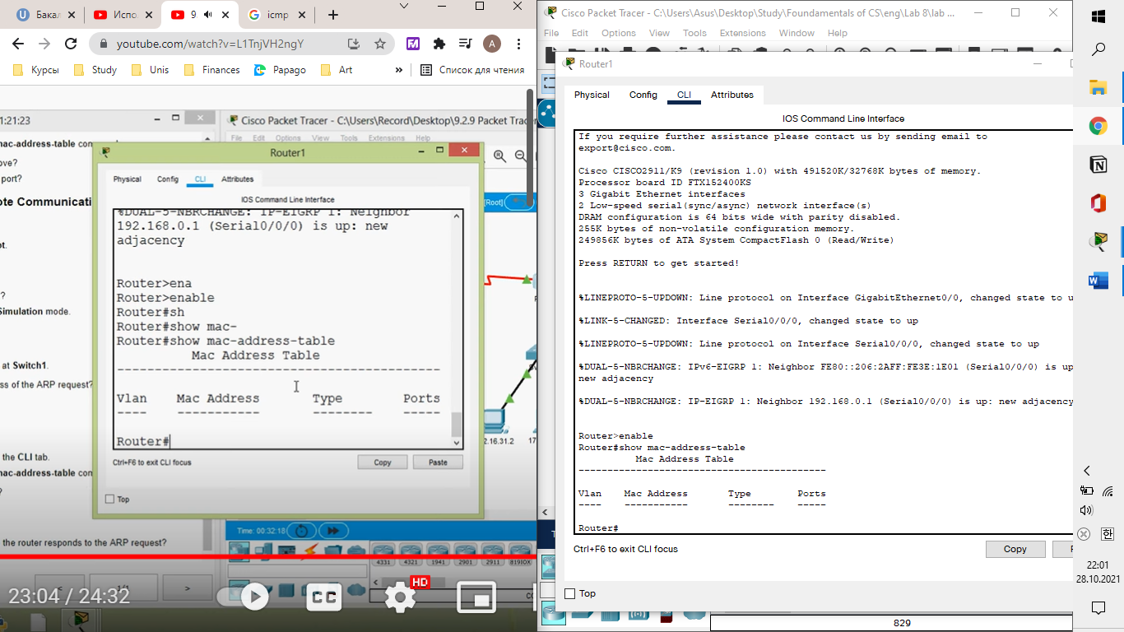

Enter the show arp command. Is there an entry for **172.16.31.2**? Yes

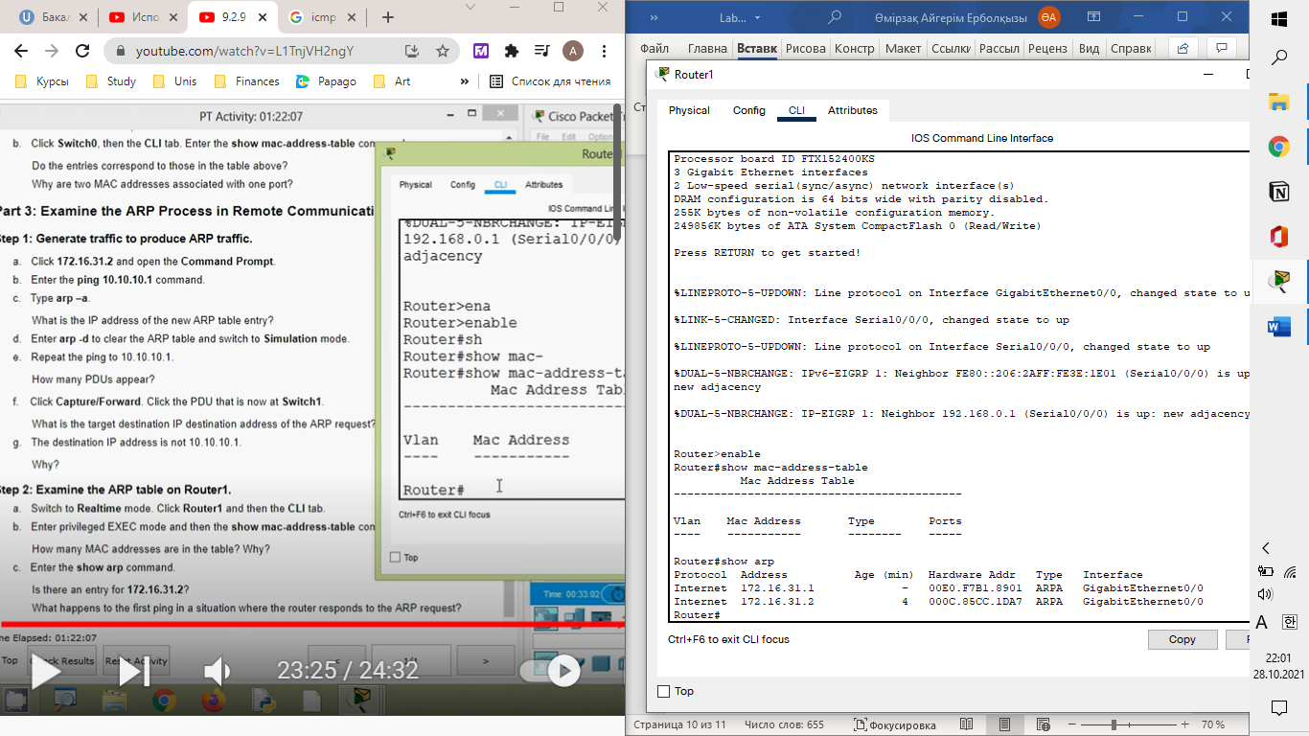  
What happens to the first ping in a situation where the router responds to the ARP request? It times out.

**Address Resolution Protocol** (ARP) is a protocol used by the Internet Protocol (IP) [RFC826], specifically IPv4, to map IP network addresses to the hardware addresses (MAC Address) used by a data link protocol.

ICMP (Internet Control Message Protocol) is an **error-reporting protocol** that network devices such as routers use to generate error messages to the source IP address when network problems prevent delivery of IP packets.

**Protocol Data Unit** (PDU) information for specific data packet at a specific time.

**Time to live** (TTL) refers to the amount of time or “hops” that a packet is set to exist inside a network before being discarded by a router. TTL is also used in other contexts including CDN caching and DNS caching.